* **Xampp started**
* **Clone in htdocs**
* **Npm run && npm run dev(done)**
* **Composer update(done)**
* **Php artisan key:generate(done)**
* **Php artisan storage:link (done)**

When **php artisan serve**

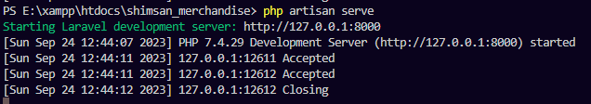

output



.env file

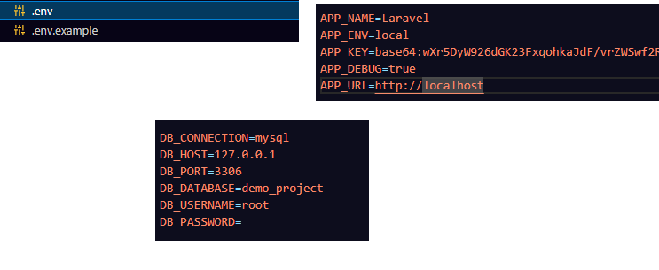

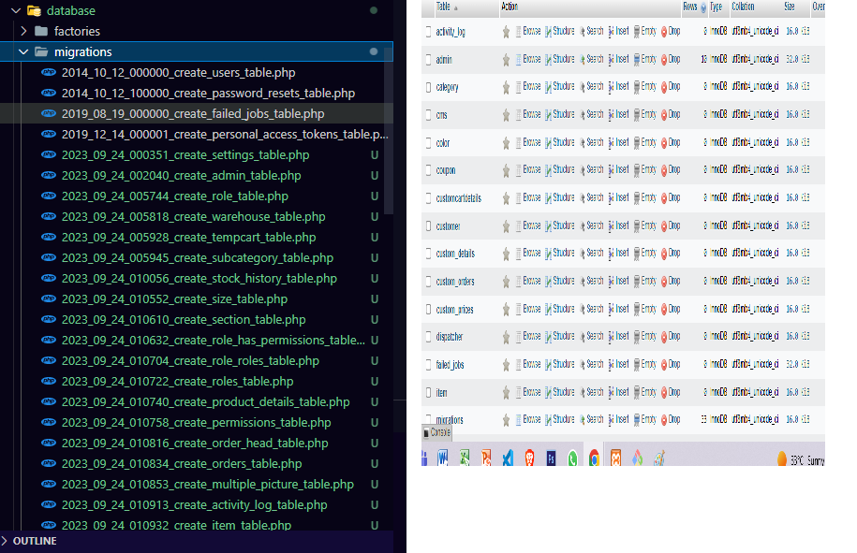

**php artisan migrate:generate --tables="category,cms,,color,coupon,customcartdetails,custom_details,customer,custom_orders,custom_prices,dispatcher,item,activity_log,multiple_picture,orders,order_head,permissions,product_details,roles,role_has_permissions,section,settings,size,stock_history,subcategory,temp_cart,admin,warehouse"**